**Purpose:**

To ensure that we have the appropriate number of temp database data files that the system would need to perform at level to minimize PAGEIOLATCH waits.

Once the email alert has been triggered, log onto the server that the email was specified for and run the following command in SSMS:

DECLARE @check BIT

DECLARE @BASEPATH NVARCHAR(300)

DECLARE @SQL_SCRIPT NVARCHAR(1000)

DECLARE @CORES INT

DECLARE @FILECOUNT INT

DECLARE @SIZE INT

DECLARE @GROWTH INT

DECLARE @ISPERCENT INT

-- TempDB mdf count equal logical cpu count

SELECT @CORES = cpu_count FROM sys.dm_os_sys_info

IF @CORES BETWEEN 9 AND 31 SET @CORES = @CORES / 2

IF @CORES >= 32 SET @CORES = @CORES / 4

--Check and set tempdb files count are multiples of 4

IF @CORES > 8 SET @CORES = @CORES - (@CORES % 4)

SET @BASEPATH = (SELECT SUBSTRING(physical_name, 1, CHARINDEX(N'tempdb.mdf', LOWER(physical_name)) - 1) DataFileLocation

FROM master.sys.master_files

WHERE database_id = 2 AND FILE_ID = 1)

SET @FILECOUNT = (SELECT COUNT(*)

FROM master.sys.master_files

WHERE database_id = 2 AND TYPE_DESC = N'ROWS')

SELECT @SIZE = size FROM master.sys.master_files WHERE database_id = 2 AND FILE_ID = 1

SET @SIZE = @SIZE / 128

SELECT @GROWTH = growth FROM master.sys.master_files WHERE database_id = 2 AND FILE_ID = 1

SELECT @ISPERCENT = is_percent_growth FROM master.sys.master_files WHERE database_id = 2 AND FILE_ID = 1

IF @ISPERCENT = 0 SET @GROWTH = @GROWTH * 8

--Current situation

PRINT 'Needed ' + CAST(@CORES AS NVARCHAR(100)) + ' TempDB data files, now there is ' + CAST(@FILECOUNT AS NVARCHAR(100)) + CHAR(10) + CHAR(13)

IF @check = 1 AND @CORES > @FILECOUNT PRINT 'Commands listed below will be executed' + CHAR(10) + CHAR(13)

WHILE @CORES > @FILECOUNT

BEGIN

SET @SQL_SCRIPT = N'ALTER DATABASE tempdb

ADD FILE (

FILENAME = ''' + @BASEPATH + 'tempdb' + RTRIM(CAST(@CORES AS NCHAR)) + '.ndf'',

NAME = tempdev' + RTRIM(CAST(@CORES AS NCHAR)) + ',

SIZE = ' + RTRIM(CAST(@SIZE AS NCHAR)) + 'MB,

FILEGROWTH = ' + RTRIM(CAST(@GROWTH AS NCHAR))

IF @ISPERCENT = 1 SET @SQL_SCRIPT = @SQL_SCRIPT + '%' ELSE SET @SQL_SCRIPT = @SQL_SCRIPT + 'KB'

SET @SQL_SCRIPT = @SQL_SCRIPT + ')'

PRINT @SQL_SCRIPT

SET @CORES = @CORES - 1

END

It will give the amount of data files that are missing in the messages tab of the SSMS. Please copy and paste it in a new window as script.

**DO NOT EXECUTE YET!**

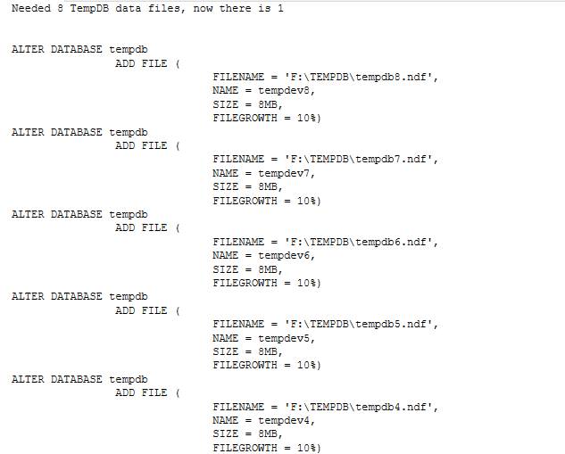

Example what is expected to see.

Log onto the server and go to the location where the other temp database is. It will be found in the filename field of the script that was pasted. (In the image above, FILENAME = 'F:\TEMPDB\tempdb8.ndf')

Ensure that the new files that will be created will match the size of the previous. In doing this please remember that all drives will need to adhere to 15% free space. If adding the data files will cause these alerts to trigger, please plan accordingly, and request the space prior to setting the data files up.

MESSAGE: NAME IF WE WANT TO ADD

MESSAGE: FILEGROWTH

Once all four point of content has been addressed and finish the script by placing some sanity checks in place.

Something like this:

USE [master];

GO

IF EXISTS (select * from sys.databases where name = 'tempdb')

BEGIN

COPY THE SCRIPT FROM PASTED WINDOW WITH MODIFICATION OF SIZE

PRINT 'SUCCESS: TEMPDB has been increased'

END

ELSE

BEGIN

PRINT 'WARNING: TEMPDB has not been modified please research'

END

Once this has been completed. If this is intended to go into Production, please ensure there is appropriate CR information outlining the change. In non-production currently, we do not need that information to outline the changes.